Windows Password Hash Extraction & Cracking

- Objective:
To use Pw Dump for extracting Windows password hashes, enabling security auditing, password policy enforcement, and detection of weak or compromised user accounts.

- Overview:
Pw Dump is a Windows utility used to extract password hashes from the Security Account Manager (SAM) database. Security professionals use it to audit account security, test password strength, and identify weak credentials. It provides the raw hashes without revealing actual passwords.

- Step-by-Step:

- Install and configure Pwdump8 on a Windows 10 virtual machine.
- Extract password hashes (LM and NTLM) from the Windows.
- Analyse and attempt to crack these hashes using Hashes.com and CrackStation.net.

Step1: Installation of Pwdump8
- Downloaded Pwdump8 from the official Open wall repository.
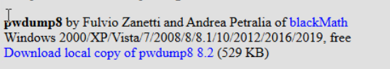

- Extracted the ZIP archive into a working directory.
- Since Pw dump is categorized as hacking/malware tool, the system by default blocked/quarantined it.

Step2: Adjusting Security Settings
- To run Pwdump8, we had to temporarily disable Windows security mechanisms:
- Disabled Windows Firewall.
- Disabled Windows Defender Real-time Protection.
- Disabled Threat & Virus Protection settings.
Step3: Executing Pwdump8
- Open Command Prompt with Administrator privileges.
- Navigated to the directory containing pwdump8.exe.
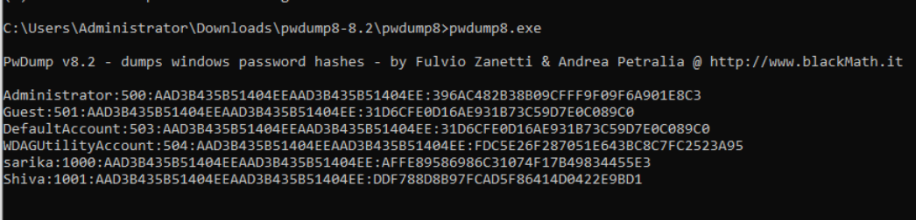
- Executed the tool by typing: pwdump8.exe

Step 4: Hash Cracking with Online Tools
Copied the extracted NTLM hashes and submitted to Hashes.com for cracking.
- 31D6CFE0D16AE931B73C59D7E0C089C0 -> Identified as empty password and paste it in crackstation.net
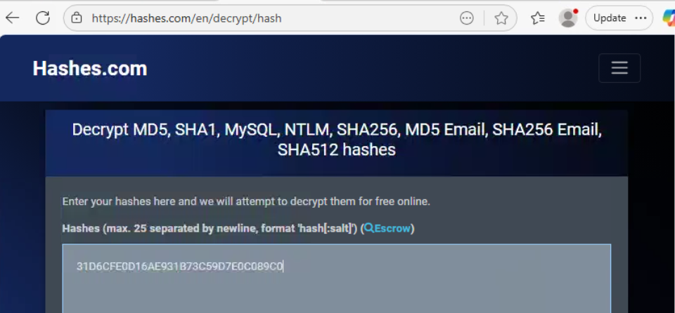

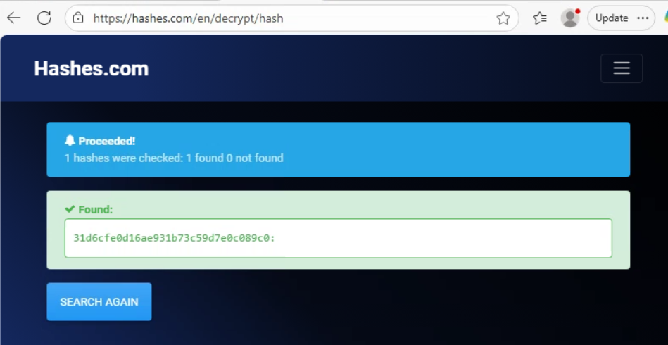
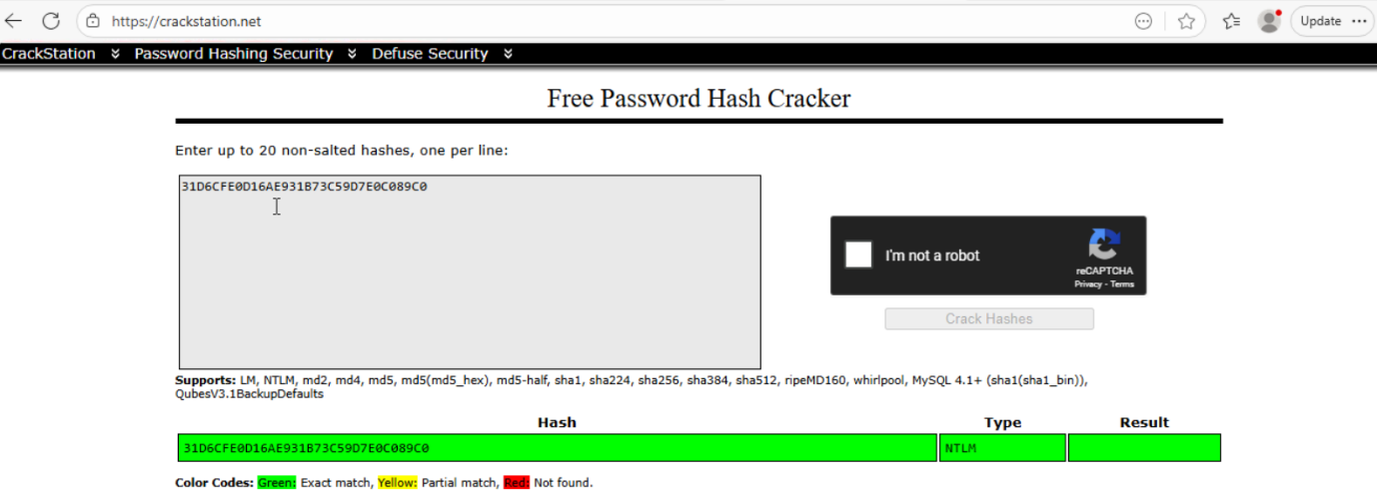

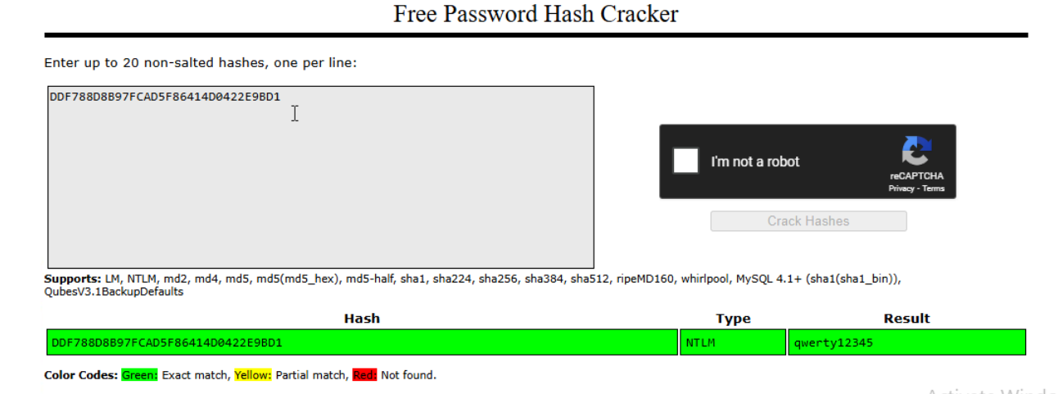
- DDF788D8B97FCAD5F86414D0422E9BD1 -> qwerty12345

- Some hashes were not found in online databases likely due to strong or uncommon passwords.

